Tuition Waiver Quick Reference Guide (Employee)

Purpose
The tuition waiver application provides employees with an online tool to submit their tuition waiver application for Human Resources to review and approve. After approval, the tuition waiver information is reported to campus accounts receivable offices for application to the student bill.

Employees will also be able to view the following information on-line:
- View Summary of Requested and Approved Tuition Waiver Credits
- View Tuition Waiver Eligibility Information
- Apply for Tuition Waiver
- View Applications
- View MnSCU Tuition Waiver Benefits for Employees Matrix and the Waiver Procedure Guide

NOTE: The tuition waiver system is not integrated with the student registration system. Normal registration procedures must be followed and the expectation is that course registration would occur prior to the completion of the tuition waiver application.

Log In
To log in to the Tuition Waiver application:
- Enter your Username (Tech Id).
- Enter your PIN or Password.
- Click Login.
- If you need help with your ID or password, use the Helpful Links.
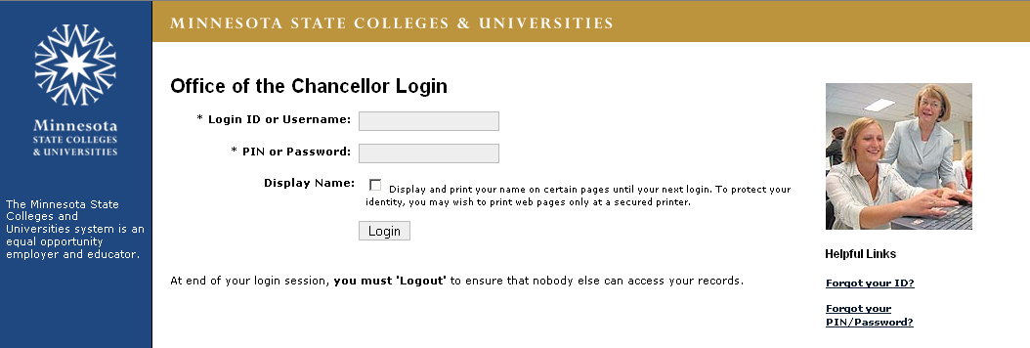
1
2
3
4

Apply For Tuition Waiver For 2008-2009
- The menu area where you have options to Apply or View Applications.
- Select the credit year the waiver applies to. Defaults to current credit year and you have the option to select future credit year.
- For the selected credit year, displays summary of Requested and Approved credits for Employee and Spouse/Dependent.
- Identifies the information you will need to apply for a waiver.
- Links to MnSCU Tuition Waiver Benefits Employees matrix and the Waiver Procedure Guide.
- Displays tuition waiver eligibility information for employee. If multiple assignments are displayed, employee selects the assignment for which the waiver applies. (Most employees will have just one assignment displayed.)

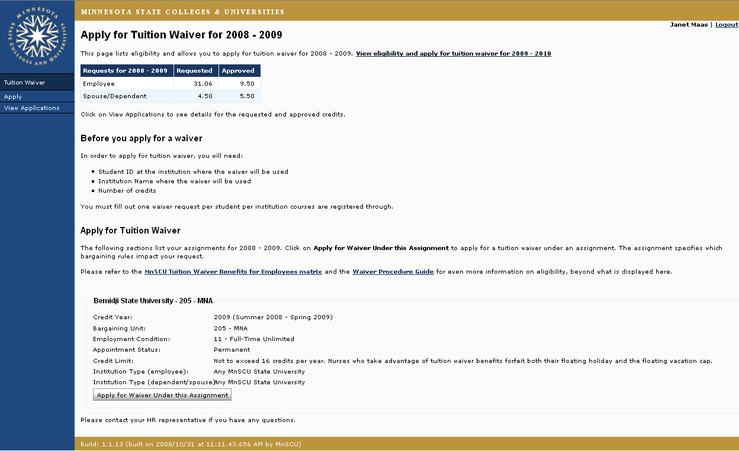
1
3
4
6
2
5

Apply For Tuition Waiver
- Displays credit year of tuition waiver application.
- Select Relationship to Employee from drop-down menu.
- Enter First 3 letters of student last name if Dependent or Spouse was selected as Relationship to Employee.
- Select institution from Courses registered through drop-down that classes will be registered at.
- Enter Student ID
- Select Academic Term from drop-down.
- Enter number of Undergraduate Credits, Graduate Credits or Doctoral Credits registering for.
- Enter Additional Info that would assist Human Resources in reviewing and approving the waiver. For example, class begins 10/1/08.
- Select Next to continue or Cancel to cancel this waiver.

*Note: You can skip steps 2-5 if you select from the list of “Previous Tuition Waiver Requests.”

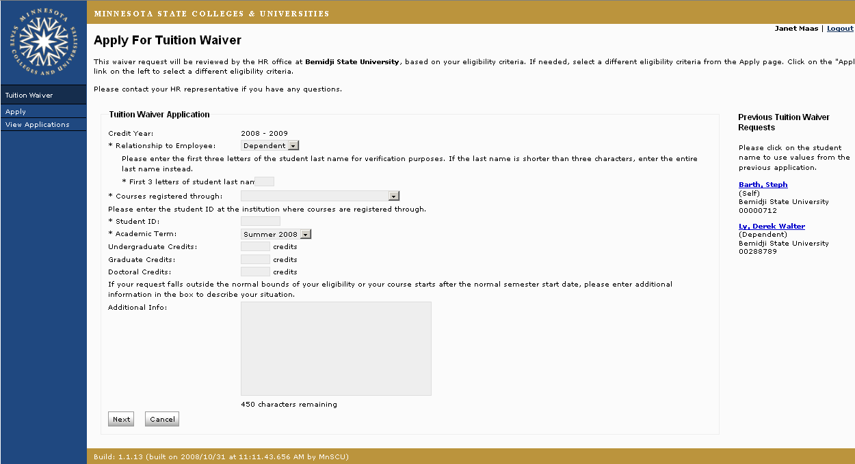
1
9
8
7
6
5
4
3
2

Confirm Information
- Displays summary of waiver application for employee review and confirmation.
- Click Edit to modify waiver information or Cancel to cancel this application.
- If the tuition waiver information is correct, click each displayed “Term and Condition” to indicate consent.
NOTE: Terms and Conditions vary depending on the information in the tuition waiver application. The “Submit Application to HR” button is disabled until all terms and conditions have been checked.
- Click Submit Application to HR.

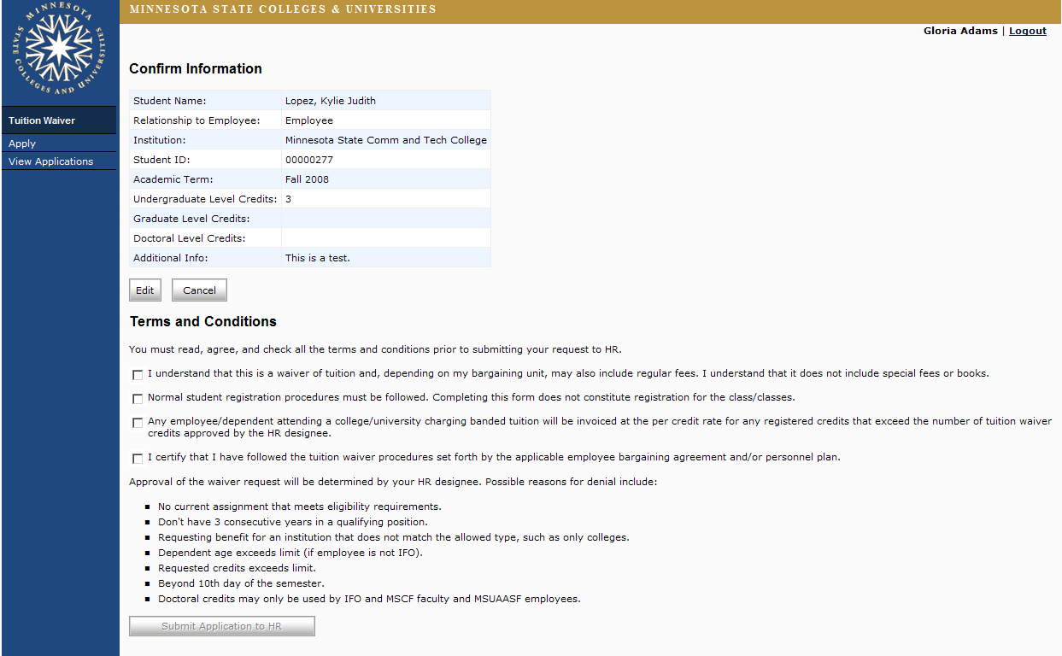
1
2
3
4

Applications
- Message area letting employee know waiver was saved.
- Displays summary information of tuition waiver applications that have been submitted to HR.
- Check the status of your waiver on this page to see when HR has approved it.

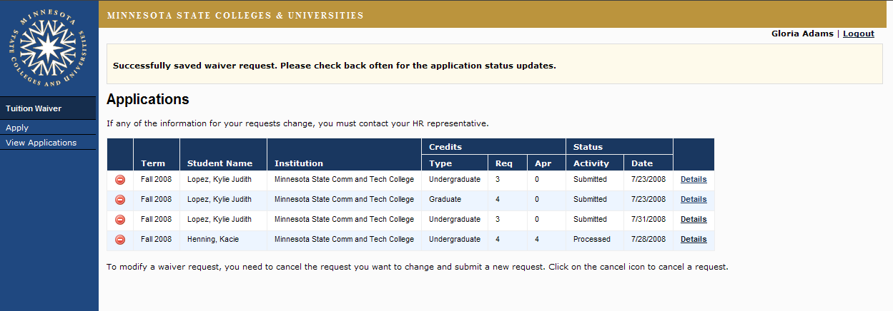
1
2
3

View Details or Update Waiver
5

To view details of or update a previously submitted waiver.
- Click View Applications in left navigation area.
- Click Details to retrieve the waiver you want to view.

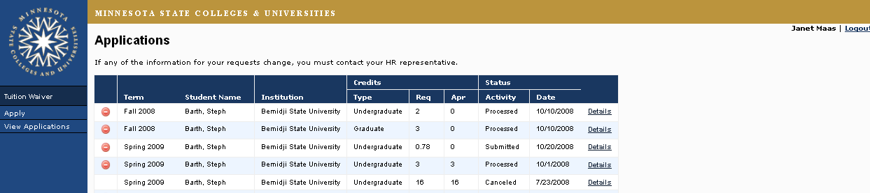
1
2

After clicking Details, the following fields are displayed:
- Displays summary of waiver information.
- Displays requested credits and approved credits for this waiver. Requested credits can be updated so long as the waiver is for a term in the current credit year. You can also add a different credit type to an existing request. Be sure to enter a reason for the update. That will assist HR in processing the request.
- Click Next to confirm information and submit the updated request to HR.

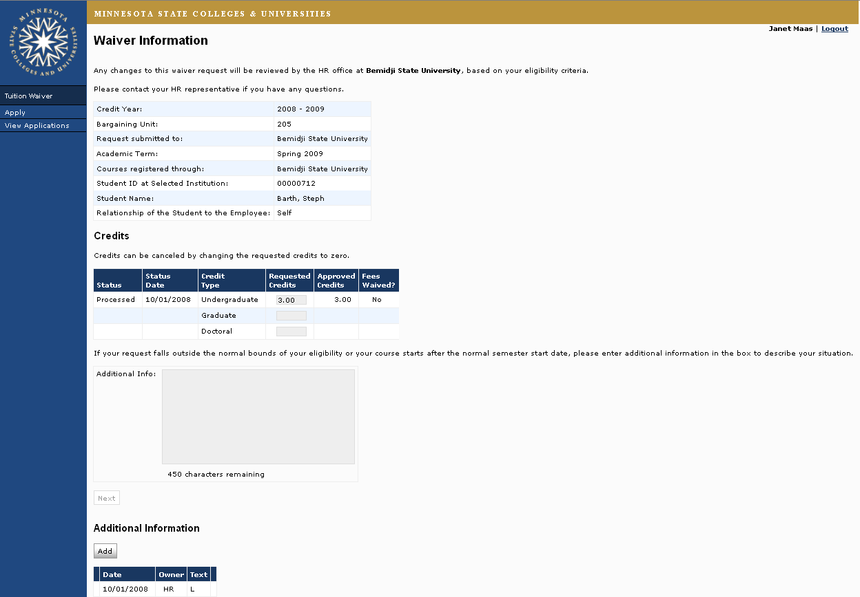
1
3
2

Cancel Waiver
5

You can cancel a previously submitted tuition waiver (so long as it is for a term in the current credit year).
- Click View Applications in left navigation area.
- Click to cancel the selected waiver. NOTE: The cancel icon no longer displays if the date for cancelling has passed.

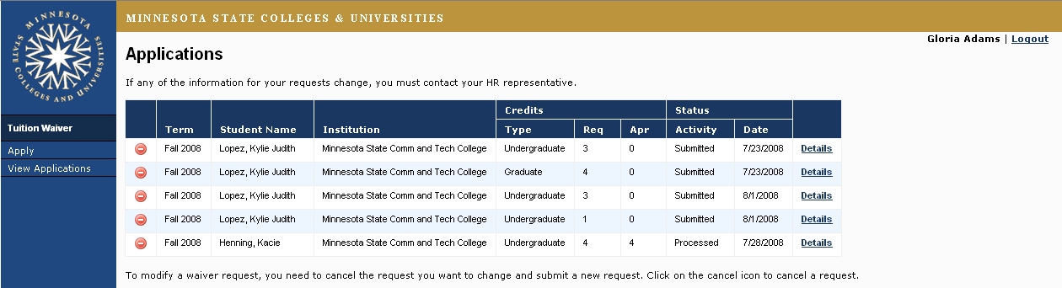
1
2

The Cancel Waiver Request page is returned
- Summary of waiver you selected to cancel.
- Displays Terms and Conditions of tuition waiver application that employee must agree to prior cancelling waiver.
- Click Submit Cancellation Request or Don’t Cancel to return to View Applications page.
NOTE: This field will be available once employee checks Term and Condition.
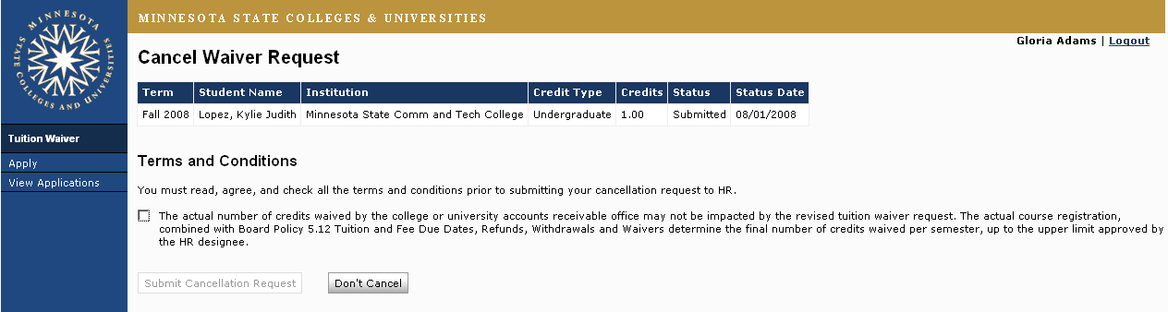
1
2
3

Waiver Processing
5

You will no longer provide the Accounts Receivable office at the campus where classes are taken with a paper tuition waiver form. They will be able to extract approved tuition waiver data from the system and process them in a more automated fashion. It's a good idea, in the short-term, to follow through with them to make sure they have processed your approved waiver.
5
5

Questions
5

If you have any questions about using the new tuition waiver module please contact your HR office.

